**Commissioned surveys on animals and plants along with the archaeological excavation survey in the prefecture in FY 2024**

**Report**

**February 2025**

**PREC Institute Inc.**

**–Table of Contents–**

1 Service overview 1

1.1 Service name 1

1.2 Place 1

1.3 Implementation period 1

1.4 Outline of the surveys 1

1.5 Details of work 1

1.6 Relevant laws and regulations, reference documents, and others 4

1) Relevant laws and regulations 4

2) Reference documents and others 4

1.7 Service implementing agency 4

1.8 Service process 4

1.9 Safety management 5

1.10 Service flow 6

2 Survey method 7

3 Survey result 9

3.1 Vegetation and environment 9

3.2 Plants 11

1) Species to be surveyed (important species) 11

2) Species to be surveyed (designated invasive alien species) 12

3.3 Animals 16

1) Species to be surveyed (important species) 16

2) Species to be surveyed (designated invasive alien species) 26

4 Estimation of the impacts of the archaeological excavation survey and examination of conservation measures 30

4.1 Conservation of the conservation 30

4.2 Conservation of plants to be surveyed 30

4.3 Conservation of animals to be surveyed 31

4.4 Measures against designated invasive alien species 31

5 Summary 32

6 Reference book 33

6.1 Bibliography 33

6.2 Control photograph 34

# Service overview

## Service name

Commissioned surveys on animals and plants along with the archaeological excavation survey in the prefecture in FY 2024

## Place

Marine Corps Air Station Futenma (Ginowan City, Okinawa) (Refer to Figure 1‑1)

## Implementation period

December 10, 2024 – February 28, 2025

## Outline of the surveys

Surveys on specific animals and plants were conducted in the area of the preliminary archaeological survey in MCAS Futenma, and the results were compiled in a report.

## Details of work

In this service, the work of the surveys shown in the particular specifications was carried out.

Details of the work is shown in Table 1‑1.

Table 1‑1 Details of work

|  |  |  |
| --- | --- | --- |
| Classification of work | Area | Details |
| Field survey  (Animal and plant survey) | Approx. 1,360 m2 | The surveys were conducted in the survey scope shown in Figure 1‑2.  (1) Confirmation of the inhabitation of the great nawab, the prefecture's designated natural monument  (2) Confirmation of the inhabitation of Kuroiwa's ground gecko, the prefecture's designated natural monument  (3) Confirmation of the inhabitation of Terrestrial Hermit Crab, Natural Monument of Japan  (4) Confirmation of the growth of food plants of the great nawab, the prefecture's designated natural monument  (5) Confirmation of the growth and inhabitation of rare animals and plants other than those listed above (species listed in the Red Data Book of the Ministry of the Environment or Okinawa Prefectural Government).  (6) Survey on vegetation communities constituting vegetation in the area  (7) Confirmation of the growth of invasive alien species |

マップ

AI によって生成されたコンテンツは間違っている可能性があります。

Source:

Topographic maps refer to “Standard Maps” published by the Geospatial Information Authority of Japan.

For military lands in Okinawa, see “Military lands in Okinawa” data published by Okinawa Prefectural Government.

"Ooyama" Gate (Gate 1)

Figure 1‑1 Location of survey site

グラフ

AI によって生成されたコンテンツは間違っている可能性があります。

Figure 1‑2 Survey coverage and survey route (actual)

## Relevant laws and regulations, reference documents, and others

### 1) Relevant laws and regulations

• Act on the Protection of Cultural Properties (Act No. 214 of 1950)

• Okinawa Prefectural Ordinance for the Protection of Cultural Properties (Ordinance No. 25 of May 15, 1972)

• Ginowan City Ordinance for the Protection of Cultural Properties (Ordinance No. 23 of December 24, 1987)

• Act on Conservation of Endangered Species of Wild Fauna and Flora (effective May 31, 2017)

• Order for Enforcement of the Act on Conservation of Endangered Species of Wild Fauna and Flora (effective February 13, 2024)

• Act on the Prevention of Adverse Ecological Impacts Caused by Designated Invasive Alien Species (Act No. 78 of 2004)

• Order for Enforcement of the Act on the Prevention of Adverse Ecological Impacts Caused by Designated Invasive Alien Species (effective April 1, 2023)

### 2) Reference documents and others

• Red List 2020 of Ministry of the Environment, Government of Japan (Office for Conservation of Endangered Species, Wildlife Division, Nature Conservation Bureau, the Ministry of the Environment; Release date: March 27, 2020)

• Revised Threatened Wildlife in Okinawa, 3rd Edition (Animals) – Red Data Okinawa – (Nature Conservation Division, Department of Environmental Affairs, Okinawa Prefectural Government, March 2017, Updated January 11, 2024)

• Revised Threatened Wildlife in Okinawa, 3rd Edition (Fungi and Plants) – Red Data Okinawa – (Nature Conservation Division, Department of Environmental Affairs, Okinawa Prefectural Government, March 2018, Updated January 11, 2024)

## Service implementing agency

This service was implemented by the following trustee.

Service operator name: Okinawa Branch Office, PREC Institute Inc.

Address: Office Izumizaki 6-B, 2-3-3 Izumizaki, Naha-shi, Okinawa

Management Engineer: HAMADA Masahiro (Professional Engineer (Environment/Natural Environment Conservation) No. 91447)

## Service process

The survey process of this service is shown in Table 1‑2.

Table 1‑2 Service schedule chart

|  |  |  |  |  |  |  |  |  |  |  |
| --- | --- | --- | --- | --- | --- | --- | --- | --- | --- | --- |
| Timing of  implementation  Items | 2024 | | | 2025 | | | | | | Remarks |
| December | | | January | | | February | | |
| Beginning | Middle | Late | Beginning | Middle | Late | Beginning | Middle | Late |
| 1. Planning and preparation |  |  |  |  |  |  |  |  |  | Preparation of service plans, etc. |
| 2. Field survey |  |  |  |  |  |  |  |  |  |  |
| 3. Compilation and organization of survey results |  |  |  |  |  |  |  | At the time of delivery of the results |  |  |
| 4. Preparation of the report |  |  | At the time of starting the service |  |  |  |  |  |  |  |
| 5. Meetings, discussions, and reports |  |  |  |  |  |  |  |  |  | Time for completion: February 28, 2025 |

## Safety management

The engineers in charge always paid close attention to safety when conducting the field survey. They took all possible measures to prevent disasters to persons and facilities, maintain sanitary conditions, and fully consider public safety. The details are as follows.

[Overall survey]

• The contents of the survey were examined in advance. After informing the surveyors of them, the service operator strived to prevent accidents throughout the survey and worked on heightening the safety consciousness through KY (danger prediction) initiatives.

• Surveyors got enough sleep and always took care of themselves. The engineers in charge checked the health condition the surveyors at the site and managed their health.

• The surveyors prepared sufficient clothing and equipment according to the survey content, season, weather, etc., and had a first-aid kit with them.

• Weather information was obtained through the Internet and television before conducting the survey.

• In response to natural disasters such as earthquakes, tsunamis, and torrential rains, the engineers in charge on the company premises worked to collect information such as advisories and warnings via the Internet and television and confirmed that the local conditions did not meet the following criteria for suspending the field surveys (Emergency Warnings, Warnings, and Advisories).

Emergency Warnings: Heavy rain, Storm, Snow-storm, Heavy snow, High waves, and Storm surge

Warnings: Heavy rain, Flood, Storm, Snow-storm, Heavy snow, High waves, and Storm surge

Advisories: Heavy rain, Flood, Gale, Gale and snow, Heavy snow, High waves, Storm surge, Thunderstorm, and Dense fog

• Surveyors always carried their mobile phones and other communicable devices, and a system was established that enabled them to communicate closely with the engineers in charge on the company premises.

[During survey on land]

• Regarding measures against habus, training on habu bite wounds was conducted beforehand, and knowledge about habus was disseminated.

• In places where dangerous organisms such as bees might inhabit and grow, the surveyors grasped the characteristics of animals and plants and countermeasures against them beforehand.

• In the field, the service operator warned the surveyors to be careful of dangerous organisms, avoided contact with them as much as possible, and strived to prevent injuries. The surveyors carried first-aid tools in their work.

[Traffic safety measures]

• Qualified persons with sufficient experience drove vehicles, and traffic laws were strictly observed to prevent traffic accidents.

• Surveyors avoided driving when they were in bad physical condition.

• They tried to give priority to local vehicles when driving.

• When parking the vehicles used for the survey, they paid attention not to disturb other vehicles.

• When parting vehicles was needed for the survey operations, they tried to confirm the safe space to park at first. When parking on the road was unavoidable, park as close as possible to the shoulder of the road and in a section with good visibility.

## Service flow

The implementation process of this service is shown in Figure 1‑3.

**1. Planning and preparation**

• Service plan

• Coordination with related organizations

**2. Field survey**

(1) Animal and plant survey

**3. Compilation and organization of survey results**

• Compilation and organization of data

• Proposal of conservation measures

**4. Preparation of the report**

**Meetings and discussions**

**Meetings and discussions**

Figure 1‑3 Flow of service implementing procedures

# Survey method

The survey was conducted on January 21, 2025. The status of the work on the target flora and fauna is shown in Figure 2‑1 . The target flora and fauna were based on the criteria shown in Table 2‑1. The detailed survey is shown in Table 2‑2

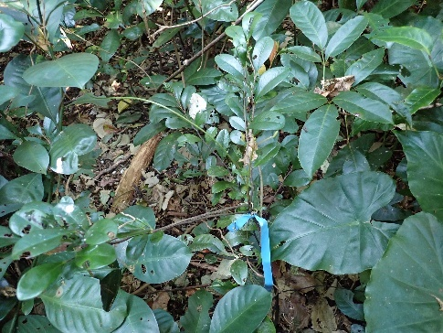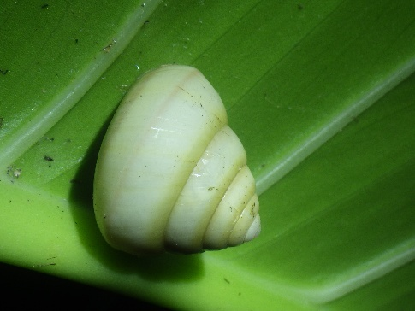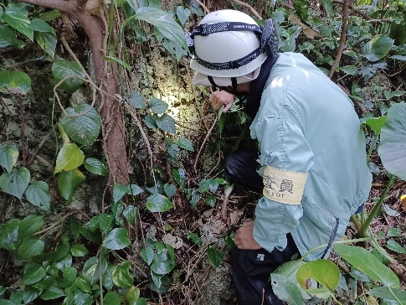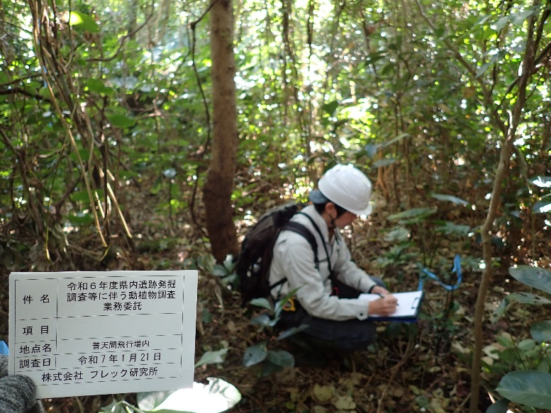

Survey the growth and habitat conditions of target plants and animals

Record the location, number of individuals, photographs, and habitat/growth conditions of the target animals and plants.

Target plants are marked with light blue sign tape

Provide a site tour of the client and report on the current status and Explanation of the direction of conservation measures associated with archaeological excavation and other work

Figure 2‑1 Status of work on target plants and animals

Table 2‑1 Selection criteria for animals and plants to be surveyed

|  |  |
| --- | --- |
| No. | Selection criteria |
| 1 | Act on the Protection of Cultural Properties (Act No. 214 of 1950) |
| 2 | Okinawa Prefectural Ordinance for the Protection of Cultural Properties(Ordinance No. 25 of May 15, 1972) |
| 3 | Ginowan City Ordinance for the Protection of Cultural Properties (Ordinance No. 23 of December 24, 1987) |
| 4 | Act on Conservation of Endangered Species of Wild Fauna and Flora (effective May 31, 2017) |
| 5 | Order for Enforcement of the Act on Conservation of Endangered Species of Wild Fauna and Flora (effective February 13, 2024) |
| 6 | Red List 2020 of Ministry of the Environment, Government of Japan (Office for Conservation of Endangered Species, Wildlife Division, Nature Conservation Bureau, the Ministry of the Environment; Release date: March 27, 2020) |
| 7 | Revised Threatened Wildlife in Okinawa, 3rd Edition (Animals) – Red Data Okinawa – (Nature Conservation Division, Department of Environmental Affairs, Okinawa Prefectural Government, March 2017, Updated January 11, 2024) |
| 8 | Revised Threatened Wildlife in Okinawa, 3rd Edition (Fungi and Plants) – Red Data Okinawa – (Nature Conservation Division, Department of Environmental Affairs, Okinawa Prefectural Government, March 2018, Updated January 11, 2024) |
| 9 | Act on the Prevention of Adverse Ecological Impacts Caused by Designated Invasive Alien Species (Act No. 78 of 2004) |
| 10 | Order for Enforcement of the Act on the Prevention of Adverse Ecological Impacts Caused by Designated Invasive Alien Species(effective April 1, 2023) |

Table 2‑2 Details of the survey

|  |  |
| --- | --- |
| Items | Details |
| Plants | • The survey was conducted mainly in the range shown in Figure 1‑2, and confirmation of the growth of the plants shown in Table 2‑1 was conducted. Confirmed plants were recorded in their position coordinates, number of individuals, and ecological information necessary for conservation. After that, they were shot.  • Confirmed plants were marked with light blue tape for signs. Trees were marked with tape for signs directly wrapped around the trunk or branch. For herbs and small individual plants, plastic stakes were placed near them and the stakes were marked. The tape for signs has a number for individual identification.  • Vegetation communities constituting vegetation in the area were classified based on main constituent species. |
| Animals | • The survey was conducted mainly in the area shown in Figure 1‑2, and the inhabitation of the animals shown in Table 2‑1 and the existence of the possibility of inhabitation were confirmed. Confirmed animals were recorded in their position coordinates, number of individuals, and ecological information necessary for conservation. After that, they were shot.  • The survey was carried out by sighting, field sign method, and confirmation of the call. |
| Overall | • In the survey, consideration was given to minimize the impact on animals and plants to be surveyed; for example, when trampling anything or finding fallen trees and stones, the surveyors returned them to their original positions. |

# Survey result

## Vegetation and environment

The survey site is a secondary forest consisting mainly of evergreen broad-leaved trees with approximately 10 m in height.

On the southern slope of the survey site, limestone is mainly showing, and forests dominated by evergreen broad-leaved trees such as Sea fig, Banyan, and Hamainubiwa, which compose natural vegetation forming on the limestone ground, are distributed. The northern part of the survey site which has gentle sloping land and valley-shaped openings facilitates the development of the soil, distributing forests dominated by evergreen broad-leaved trees such as Oobagi and Akagi. Unused tomb is left on the southwest side of the survey site, and forests dominated by evergreen broad-leaved trees such as Oobagi and Akagi are also found in the surrounding area.

|  |  |
| --- | --- |
| 緑の木々  AI によって生成されたコンテンツは間違っている可能性があります。  forest edge | 森の中の木  AI によって生成されたコンテンツは間違っている可能性があります。  In forest (limestone area) |
| 森の中の木  AI によって生成されたコンテンツは間違っている可能性があります。  In forest (valley opening) | 森の中を歩いている  AI によって生成されたコンテンツは間違っている可能性があります。  tomb |

Figure 3‑1 Vegetation and environment of the study area

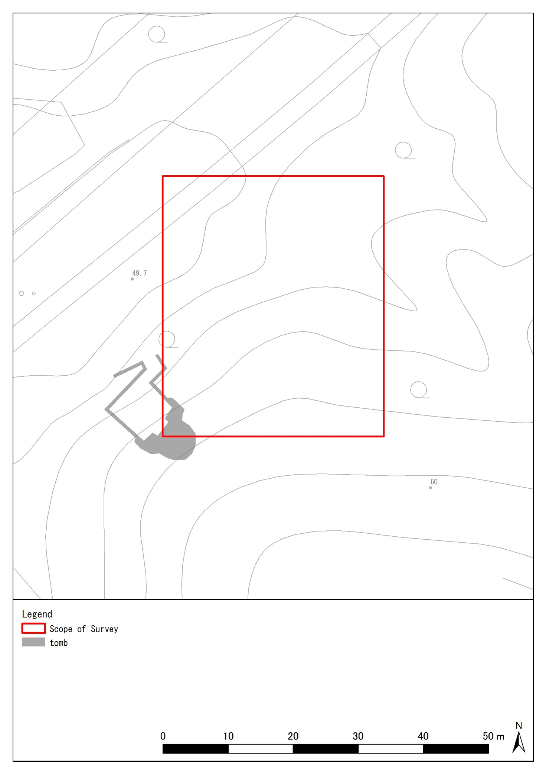

Figure 3‑2 Location of the tomb

## Plants

### 1) Species to be surveyed (important species)

A list of identified plants is shown in Table 3‑1 and a list of identified species of identified plants is shown in Table 3‑2. Points where species were identified are shown in Figure 3‑3. In addition, the label number of the plant species to be surveyed and the latitude and longitude of the places where they were identified are shown by the geodetic reference system in Table 3‑3, TablE 3‑4. The ecological information on the plant species described in Table 3‑1 was taken from the Red Data Book 2014 (the Ministry of the Environment, 2014) and the Okinawa Prefecture Red Data Book (Nature Conservation Division, Department of Environmental Affairs, Okinawa Prefectural Government, 2018). If it is not described in those documents, it was taken from other documents and the source of the citation was specified.

In this survey, two species of plants to be surveyed were identified, including two native woody plants (Kuwanohaenoki and Ryukyu Kokutan). Among them, the plant species with the largest number of individuals was Ryukyu Kokutan, with 39 plants. In addition, Kuwanohaenoki is a food plant for the larva of the great nawab, which is designated as a Natural Monument of Okinawa Prefecture, and a tree with a height of 10 meters has been confirmed.

Table 3‑1 List of confirmed species (plants to be surveyed)

|  |  |  |  |  |  |  |  |  |  |  |  |
| --- | --- | --- | --- | --- | --- | --- | --- | --- | --- | --- | --- |
| No. | Division | Family | Common name | Natural monument | | | Endangered species of wild flora and fauna in Japan* 1 | The Ministry of the Environment RL (2020) * 2 | Okinawa RDB (2024) * 3 | Food plants of the great nawab | Population |
| Nation | Prefecture | City |
| 1 | Spermatophyte | Ulmaceae | Kuwanohaenoki |  |  |  |  |  |  | ○ | 9 |
| 2 | Ebenaceae | Ryukyu Kokutan |  |  |  |  | NT |  |  | 39 |
| Total | 1 division | 2 families | 2 species | 0 species | 0 species | 0 species | 0 species | 1 species | 0 species | 1 species | 48 individuals |

*1 Endangered species of wild flora and fauna in Japan “Act on Conservation of Endangered Species of Wild Fauna and Flora”

Domestic: Endangered species of wild flora and fauna in Japan, International: Internationally endangered species of wild flora and fauna

*2 The Ministry of the Environment RL: Red List 2020 (the Ministry of the Environment, 2020)

EX: Extinct species → Species considered to be extinct in Japan

EW: Extinct in the Wild → Species known only to survive in captivity, in cultivation, or in a wild state clearly outside their natural distribution range

CR: Threatened IA (Critically Endangered) → Extremely high risk of extinction in the wild in the very near future

EN: Threatened IB (Endangered) → Not as severe as Threatened IA, but at high risk of extinction in the wild in the near future.

VU: Threatened II (Vulnerable) → Species at increasing risk of extinction

NT: Near Threatened → A species at low risk of extinction at present, but may transition to Threatened categories depending on changes in habitat conditions.

DD: Data Deficient → Species for which sufficient data are not available for assessment

*3 Okinawa RDB: “Revised Threatened Wildlife in Okinawa (Red Data Okinawa) 3rd Edition -Animals-” (Okinawa Prefectural Government, 2018)

EX: Extinct species → Species considered to be extinct in Okinawa

EN: Threatened I (Endangered) → High risk of extinction in the wild in the near future.

VU: Threatened II (Vulnerable) → Species at increasing risk of extinction

NT: Near Threatened → Species with a vulnerable foundation for survival

DD: Data Deficient → Species for which sufficient data are not available for assessment

LP: Local Population → Locally isolated population with a high probability of extinction

Table 3‑2 List of confirmed species of target plants

|  |  |
| --- | --- |
| 木の枝  AI によって生成されたコンテンツは間違っている可能性があります。 | ■morphological characteristics  It is a deciduous, tall tree with an erect trunk, 8-15 m tall, and its twigs are almost hairless. The leaves are ovate-oblong, pointed at the tip, and alternate with bluntly serrated superserrate margins. The kernels are small and spherical, ripening to orange-yellow (Ikehara 1979).  ■distribution range  Distributed in Yamaguchi Prefecture, Kyushu, Okinawa Island, Iheya Island, Izena Island, Ie Island, Mizuna Island, Sesoko Island, Ike Island, Kutaka Island, Aguni Island, Amami Oshima, Kikai Island, Tokunoshima, Okinoerabu Island, Kita Daito Island, Miyako Island, Ishigaki Island, Iriomote Island, Hateruma Island, Yonaguni Island (Botanical Database of the Ryukyus 2018)  ■habitat  Grows in forest margins and light forests in lowland to growing areas, often in limestone areas (Okawa and Hayashi 2016). |
| Common name: Kuwanohaenoki  Scientific name: *Celtis boninensis*  Family name: Asaceae  category  Food tree of Futaochou |
| 茂みの中にいる  AI によって生成されたコンテンツは間違っている可能性があります。 | ■morphological characteristics  It is a montane sub-tree, but is widely cultivated as a garden tree. The bark is blackish brown and the annual branches have silky hairs. The leaves are ovate-ovate, stiff, and have a slightly concave margin. Fruits are elliptic, 1 cm long or less, and ripen to a reddish-red color (Ikehara 1979).  ■distribution range  Miyako Island, Ogami Island, Ishigaki Island, Iriomote Island, Kohama Island, Aragusuku Island, Hateruma Island, Yonaguni Island (Botanical Database of the Ryukyus 2018)  ■habitat  Grows in lowland to mountainous forests. Many individuals have become wild from planting (Okawa and Hayashi 2016). |
| Common name: Ryukyu kokutan  (Also known as Yaeyama Kokutan)  Scientific name: *Diospyros egbert -walkeri*  Family name: Oysteraceae  category  The Ministry of the Environment RL :  Near Threatend (NT) |

### 2) Species to be surveyed (designated invasive alien species)

As a result of this survey, no specific invasive alien species have been identified within the study area.

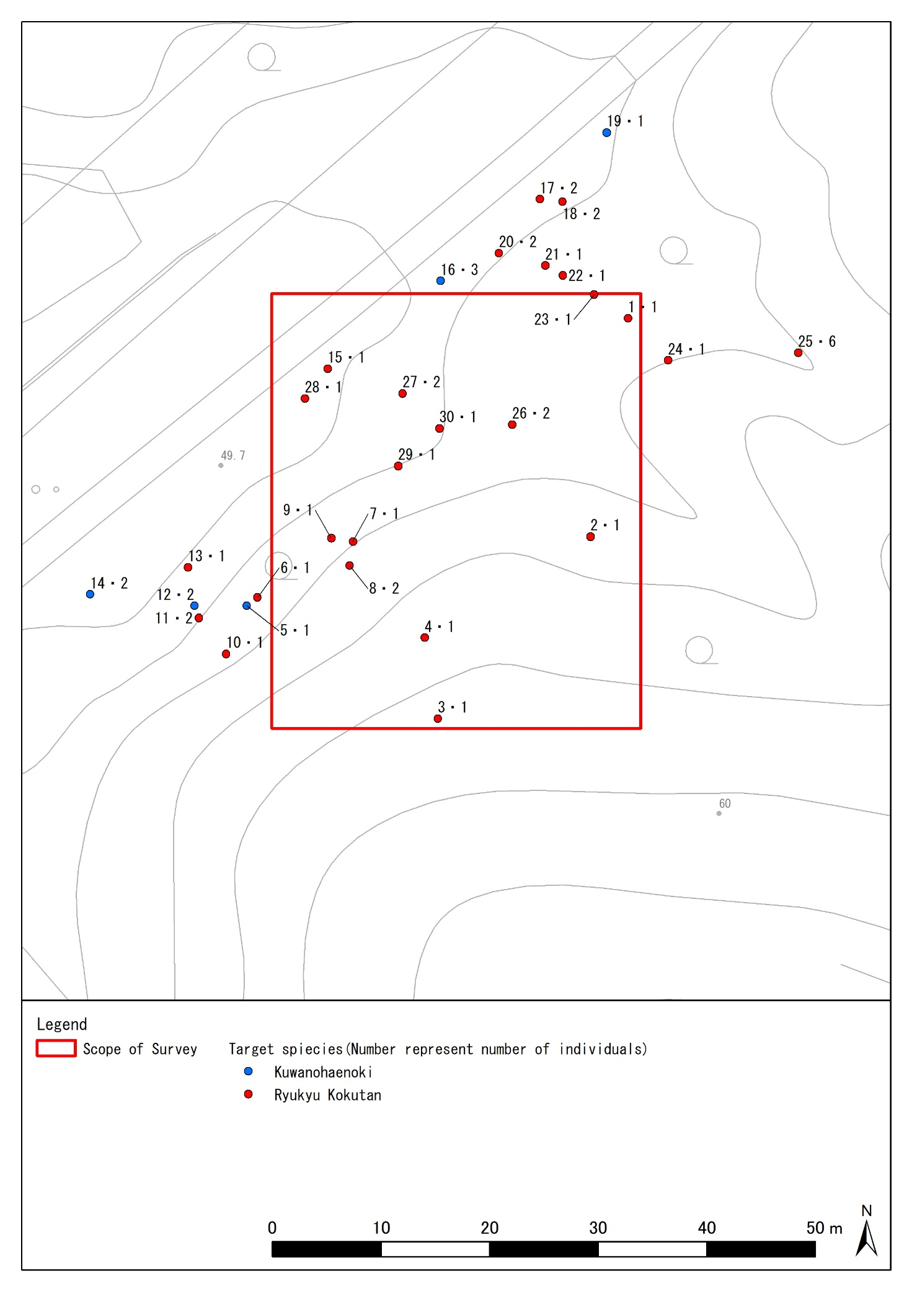

Figure 3‑3 Surveyed species confirmation sites (plants)

Table 3‑3 Label numbers of target plants and coordinates of the location to be checked (in World Geodetic System 60 decimal notation)

|  |  |  |  |  |
| --- | --- | --- | --- | --- |
| No. | Name of a species | population size | coordinate | |
| 1 | Ryukyu Kokutan | 1 | N26°16′54.73200″ | E127°45′16.67520″ |
| 2 | Ryukyu Kokutan | 1 | N26°16′54.08040″ | E127°45′16.54920″ |
| 3 | Ryukyu Kokutan | 1 | N26°16′53.53680″ | E127°45′16.04160″ |
| 4 | Ryukyu Kokutan | 1 | N26°16′53.77800″ | E127°45′15.99840″ |
| 5 | Kuwanohaenoki | 1 | N26°16′53.87520″ | E127°45′15.40800″ |
| 6 | Ryukyu Kokutan | 1 | N26°16′53.90040″ | E127°45′15.44400″ |
| 7 | Ryukyu Kokutan | 1 | N26°16′54.06600″ | E127°45′15.76080″ |
| 8 | Ryukyu Kokutan | 2 | N26°16′53.99400″ | E127°45′15.75000″ |
| 9 | Ryukyu Kokutan | 1 | N26°16′54.07680″ | E127°45′15.68880″ |
| 10 | Ryukyu Kokutan | 1 | N26°16′53.73120″ | E127°45′15.33960″ |
| 11 | Ryukyu Kokutan | 2 | N26°16′53.83920″ | E127°45′15.24960″ |
| 12 | Kuwanohaenoki | 2 | N26°16′53.87520″ | E127°45′15.23520″ |
| 13 | Ryukyu Kokutan | 1 | N26°16′53.99040″ | E127°45′15.21360″ |
| 14 | Kuwanohaenoki | 2 | N26°16′53.91005″ | E127°45′14.88846″ |
| 15 | Ryukyu Kokutan | 1 | N26°16′54.58325″ | E127°45′15.67840″ |
| 16 | Kuwanohaenoki | 3 | N26°16′54.84507″ | E127°45′16.05304″ |
| 17 | Ryukyu Kokutan | 2 | N26°16′55.08840″ | E127°45′16.38360″ |
| 18 | Ryukyu Kokutan | 2 | N26°16′55.08120″ | E127°45′16.45920″ |
| 19 | Kuwanohaenoki | 1 | N26°16′55.28812″ | E127°45′16.60532″ |
| 20 | Ryukyu Kokutan | 2 | N26°16′54.92787″ | E127°45′16.24744″ |
| 21 | Ryukyu Kokutan | 1 | N26°16′54.89040″ | E127°45′16.40160″ |
| 22 | Ryukyu Kokutan | 1 | N26°16′54.86160″ | E127°45′16.45920″ |
| 23 | Ryukyu Kokutan | 1 | N26°16′54.80400″ | E127°45′16.56360″ |
| 24 | Ryukyu Kokutan | 1 | N26°16′54.60600″ | E127°45′16.80840″ |
| 25 | Ryukyu Kokutan | 6 | N26°16′54.62760″ | E127°45′17.24040″ |
| 26 | Ryukyu Kokutan | 2 | N26°16′54.41520″ | E127°45′16.29000″ |
| 27 | Ryukyu Kokutan | 2 | N26°16′54.50880″ | E127°45′15.92640″ |
| 28 | Ryukyu Kokutan | 1 | N26°16′54.49440″ | E127°45′15.60240″ |
| 29 | Ryukyu Kokutan | 1 | N26°16′54.29280″ | E127°45′15.91200″ |
| 30 | Ryukyu Kokutan | 1 | N26°16′54.40440″ | E127°45′16.04880″ |

TablE 3‑4 Label numbers of target plants and coordinates of the confirmation location (Japan geodetic system in 60 decimal notation)

|  |  |  |  |  |
| --- | --- | --- | --- | --- |
| No. | Name of a species | population size | coordinate | |
| 1 | Ryukyu Kokutan | 1 | N26°16′40.63398″ | E127°45′23.39551″ |
| 2 | Ryukyu Kokutan | 1 | N26°16′39.98233″ | E127°45′23.26946″ |
| 3 | Ryukyu Kokutan | 1 | N26°16′39.43870″ | E127°45′22.76180″ |
| 4 | Ryukyu Kokutan | 1 | N26°16′39.67992″ | E127°45′22.71860″ |
| 5 | Kuwanohaenoki | 1 | N26°16′39.77714″ | E127°45′22.12816″ |
| 6 | Ryukyu Kokutan | 1 | N26°16′39.80234″ | E127°45′22.16416″ |
| 7 | Ryukyu Kokutan | 1 | N26°16′39.96795″ | E127°45′22.48100″ |
| 8 | Ryukyu Kokutan | 2 | N26°16′39.89594″ | E127°45′22.47019″ |
| 9 | Ryukyu Kokutan | 1 | N26°16′39.97875″ | E127°45′22.40899″ |
| 10 | Ryukyu Kokutan | 1 | N26°16′39.63313″ | E127°45′22.05975″ |
| 11 | Ryukyu Kokutan | 2 | N26°16′39.74114″ | E127°45′21.96975″ |
| 12 | Kuwanohaenoki | 2 | N26°16′39.77715″ | E127°45′21.95535″ |
| 13 | Ryukyu Kokutan | 1 | N26°16′39.89236″ | E127°45′21.93375″ |
| 14 | Kuwanohaenoki | 2 | N26°16′39.81201″ | E127°45′21.60858″ |
| 15 | Ryukyu Kokutan | 1 | N26°16′40.48524″ | E127°45′22.39862″ |
| 16 | Kuwanohaenoki | 3 | N26°16′40.74708″ | E127°45′22.77330″ |
| 17 | Ryukyu Kokutan | 2 | N26°16′40.99042″ | E127°45′23.10390″ |
| 18 | Ryukyu Kokutan | 2 | N26°16′40.98322″ | E127°45′23.17951″ |
| 19 | Kuwanohaenoki | 1 | N26°16′41.19015″ | E127°45′23.32565″ |
| 20 | Ryukyu Kokutan | 2 | N26°16′40.82988″ | E127°45′22.96772″ |
| 21 | Ryukyu Kokutan | 1 | N26°16′40.79240″ | E127°45′23.12189″ |
| 22 | Ryukyu Kokutan | 1 | N26°16′40.76360″ | E127°45′23.17950″ |
| 23 | Ryukyu Kokutan | 1 | N26°16′40.70599″ | E127°45′23.28390″ |
| 24 | Ryukyu Kokutan | 1 | N26°16′40.50797″ | E127°45′23.52871″ |
| 25 | Ryukyu Kokutan | 6 | N26°16′40.52956″ | E127°45′23.96075″ |
| 26 | Ryukyu Kokutan | 2 | N26°16′40.31717″ | E127°45′23.01026″ |
| 27 | Ryukyu Kokutan | 2 | N26°16′40.41078″ | E127°45′22.64663″ |
| 28 | Ryukyu Kokutan | 1 | N26°16′40.39639″ | E127°45′22.32261″ |
| 29 | Ryukyu Kokutan | 1 | N26°16′40.19476″ | E127°45′22.63222″ |
| 30 | Ryukyu Kokutan | 1 | N26°16′40.30637″ | E127°45′22.76904″ |

## Animals

### 1) Species to be surveyed (important species)

A list of identified animals is shown in Table 3‑5 and a list of identified species of animals is shown in Table 3‑6. Points where species were identified are shown in Figure 3‑4, Figure 3‑5. In addition, the latitude and longitude of the places where the animals to be surveyed were identified are shown by the geodetic reference system in Table 3‑7, TablE 3‑8. The ecological information on the animal species described in Table 3‑6 was taken from the Red Data Book 2014 (the Ministry of the Environment, 2014) and the Okinawa Prefecture Red Data Book (Nature Conservation Division, Department of Environmental Affairs, Okinawa Prefectural Government, 2017). If it is not described in those documents, it was taken from other documents and the source of the citation was specified.

In this survey, 10 species of animals to be surveyed were identified (1 species of mammal, 4 species of birds, and 5 species of shellfish). However, natural monuments such as the great nawab (the prefecture's designated natural monument), Kuroiwa's ground gecko (the prefecture's designated natural monument), and Terrestrial Hermit Crabs(natural monument of Japan) were not confirmed.

An individual of Orii's flying foxes was not visually confirmed, but pellets, which are leftover fibrous plant food, were confirmed. A large number of pellets were found in the survey site, and it can be considered that the site might be maintained as a habitat for Orii's flying foxes.

Table 3‑5 List of important species confirmed (animals to be surveyed)

|  |  |  |  |  |  |  |  |  |  |  |
| --- | --- | --- | --- | --- | --- | --- | --- | --- | --- | --- |
| No. | Classification | Family | Common name | Natural monument | | | Endangered species of wild flora and fauna in Japan* 1 | The Ministry of the Environment RL (2020) * 2 | Okinawa RDB (2024) * 3 | Population |
| Nation | Prefecture | City |
| 1 | Mammal | Pteropodidae | Orii's flying-fox |  |  |  |  |  | NT | －* 4 |
| 2 | Birds | Pandionidae | Osprey |  |  |  |  | NT | NT | 1 |
| 3 | Accipitridae | Grey-faced buzzard |  |  |  |  | VU | VU | 2 |
| 4 | Falconidae | Falcons |  |  |  | ○ | VU | VU | 1 |
| 5 | Cettiidae | Japanese bush warbler  (Daido bush warbler) |  |  |  |  | (DD) |  | 1 |
| 6 | Shellfish | Hydrocenidae | Fukuda-Goma-okatanishi |  |  |  |  | NT |  | 157 |
| 7 | Cyclophoridae | Aomi-okatanishi |  |  |  |  | NT | NT | 35 |
| 8 | a species of yamatanishi |  |  |  |  | VU | NT | 300 |
| 9 | Diplommatinidae | Ryukyu gomakai |  |  |  |  | VU |  | 60 |
| 10 | Camaenidae | Shirayuki Yamatakamaimai |  |  |  |  | EN | VU | 2 |
| Total | 3 classifications | 9 families | 10 species | 0 species | 0 species | 0 species | 1 species | 9 species | 6 species | 559 individuals |

*1 Endangered species of wild flora and fauna in Japan “Act on Conservation of Endangered Species of Wild Fauna and Flora”

Domestic: Endangered species of wild flora and fauna in Japan, International: Internationally endangered species of wild flora and fauna

*2 The Ministry of the Environment RL: Red List 2020 (the Ministry of the Environment, 2020)

EX: Extinct species → Species considered to be extinct in Japan

EW: Extinct in the Wild → Species known only to survive in captivity, in cultivation, or in a wild state clearly outside their natural distribution range

CR: Threatened IA (Critically Endangered) → Extremely high risk of extinction in the wild in the very near future

EN: Threatened IB (Endangered) → Not as severe as Threatened IA, but at high risk of extinction in the wild in the near future.

VU: Threatened II (Vulnerable) → Species at increasing risk of extinction

NT: Near Threatened →A species at low risk of extinction at present, but may transition to Threatened categories depending on changes in habitat conditions.

DD: Data Deficient → Species for which sufficient data are not available for assessment

LP: Threatened Local Population → Locally isolated population with a high probability of extinction

*3 Okinawa RDB: “Revised Threatened Wildlife in Okinawa (Red Data Okinawa) 3rd Edition -Animals-” (Okinawa Prefectural Government, 2018)

EX: Extinct species → Species considered to be extinct in Okinawa

EN: Threatened I (Endangered) → High risk of extinction in the wild in the near future.

VU: Threatened II (Vulnerable) → Species at increasing risk of extinction

NT: Near Threatened → Species with a vulnerable foundation for survival

DD: Data Deficient → Species for which sufficient data are not available for assessment

LP: Local Population → Locally isolated population with a high probability of extinction

*4 The number of individuals is unknown, as the confirmation of individuals is based on field signs (pellets) rather than visual confirmation.

Table 3‑6 (1/5) List of confirmed species of target animals

|  |  |
| --- | --- |
| ブロッコリーのクローズアップ  AI によって生成されたコンテンツは間違っている可能性があります。  **\*Photo: Pellit** | ■Morphological Features  The hairs on the upper part of the body, mainly on the neck, are distinctly light-colored and extend to the dorsal surface of the thighs, reaching a dorsal body hair length of more than 20 mm, with a forearm length of 130-147 mm and a body weight of 337-583 g.  ■Distribution Area  Distributed on Okinawa Island and neighboring islands.  Habitat  They require an arboreal environment because they rest during the day by hanging from high branches in the forest and move to a wooded environment at night to feed on fruit and nectar. However, they also use residential areas and parks as feeding grounds. (Nature Conservation Division, Department of Environment, Okinawa Prefecture, 2017) |
| Common name: Orii's flying-fox  Scientific name: *Pteropus dasymallus inopinatus*  Classification: Pteropodidae (winged bats)  category  The Ministry of the Environment RL : None  Okinawa RDB: Near Threatened (NT) |
| 飛行機が空を飛んでいる鳥  AI によって生成されたコンテンツは間違っている可能性があります。 | ■Morphological Features  The upper surfaces of the back and wings are blackish brown and the lower surfaces are white. It has short crown feathers on its head and a blackish-brown band on its breast. Beak and legs are grayish black.  ■Distribution Area  In Japan, it breeds almost throughout the country except in Okinawa. Although summering individuals are often seen in the prefecture, nesting has not been confirmed, and it is thought that they are mainly wintering birds.  Habitat  Nesting sites and surrounding areas such as beaches, lakes, and marshes where food can be gathered are necessary.  (Nature Conservation Division, Department of Environment, Okinawa Prefecture, 2017) |
| Common name: Osprey  Scientific name: *Pandion haliaetus*  Classification: Pandionidae （Accipitriformes）  category  The Ministry of the Environment RL:  Near Threatened (NT)  Okinawa RDB: Near Threatened (NT) |

Table 3‑6 (2/5) List of confirmed species of target animals

|  |  |
| --- | --- |
| 飛行機が空を飛んでいる鳥  AI によって生成されたコンテンツは間違っている可能性があります。 | ■Morphological Features  A medium-sized bird of prey with a total length of 47 cm for males and 50 cm for females, and a wing span of 105-115 cm. The male has a grayish-brown head with a brownish-brown upper surface and breast. The bill is grayish black with a yellow wax membrane and iris. Throat white with a blackish-brown central gill rake. The belly is white with brownish-brown transverse spots. Tail with three thick blackish-brown yellow stripes. Wing undersides white with a narrow dark brown transverse stripe on the windlass and a blackish brown tip on the first row of windlass.  ■Distribution Area  They breed in Japan, the Korean Peninsula, and eastern China, and winter in the Nansei Islands, southern China, and Southeast Asia. In Japan, it migrates and breeds as a summer bird from Honshu (southern Tohoku region) to Shikoku and Kyushu. In the prefecture, it is a winter bird and a traveler.  Habitat  A cohesive forest, such as a rufous pine forest or a broadleaf forest, is needed to provide a resting place during the migratory season.  (Nature Conservation Division, Department of Environment, Okinawa Prefecture, 2017) |
| Common name: Grey-faced buzzard  Scientific name: *Butastur indicus*  Classification: Accipitridae（Hawks）  category  The Ministry of the Environment RL:  Threatened II (VU)  Okinawa RDB: Threatened II (VU) |
| 飛行機が空を飛んでいる鳥  AI によって生成されたコンテンツは間違っている可能性があります。 | ■Morphological Features  The head, back, and tail are grayish black, and the throat, breast, abdomen, and lower surfaces of the wings are grayish white with blackish brown transverse spots. Young birds are brownish on the upper surface and yellowish-white on the lower surface with blackish-brown longitudinal spots.  ■Distribution Area  It is distributed from Eastern Siberia to the coast of the Gulf of Okhotsk, Kamchatka, Sakhalin, Korean Peninsula, etc. In Japan, it breeds north of Kyushu. A winter bird in the prefecture.  Habitat  Hunting grounds around steep coastal cliffs, forests, wetlands and rice paddies.  (Nature Conservation Division, Department of Environment, Okinawa Prefecture, 2017) |
| Common name: Falcons  Scientific name: *Falco peregrinus*  Classification: Falconidae（Falconiformes）  category  Domestic: Endangered species of wild flora and fauna in Japan  The Ministry of the Environment RL:  Threatened Ⅱ(VU)  Okinawa RDB: Threatened Ⅱ (VU) |

Table 3‑6 (3/5) List of confirmed species of target animals

|  |  |
| --- | --- |
| 葉の上にいる鳥  AI によって生成されたコンテンツは間違っている可能性があります。 | ■Morphological Features  The total length is about 15 cm, and the wing length differs between males and females, with males having longer wings. There are several subspecies of this species, but the one that breeds on Okinawa Island is thought to be *Cettia diphone* restricta.  ■Distribution Area  It is believed to be widely distributed in East Asia.  Habitat  It is believed to inhabit forests and other habitats from plains to mountains.  (Nature Conservation Division, Department of Environment, Okinawa Prefecture, 2017)  (Abe, 1984) |
| Common name: Japanese bush warbler (Daido bush warbler)  Scientific name: *Cettia diphone*  Classification: Cettiidae（Passeriformes）  category  The Ministry of Environment RL : Data Deficient（DD）  Okinawa RDB: None |
| 草, グリーン, 小さい, 鳥 が含まれている画像  AI によって生成されたコンテンツは間違っている可能性があります。 | ■Morphological Features  Shell minute (about 2 mm in diameter), with high spiracles, no umbilical pits, and with fine or smooth spiral veins on the shell surface, pale red or muddy yellow. The cap is calcareous with barbed projections. This species can be distinguished from Gomaokatanishi, which is widely distributed in the Ryukyu Islands, by the presence of distinct spiral veins on the shell surface.  ■Distribution Area  It is found only on the island of Okinawa.  Habitat  It is found on limestone walls and gravel in limestone areas, as well as under deciduous leaves on the forest floor.  (Okinawa Prefecture Environment, 2005) |
| Common name: Fukuda-Goma-okatanishi  Scientific name: *Georissa hukudai*  Classification: Hydrocenidae（Neritoida）  category  The Ministry of the Environment RL :  Near Threatened (NT)  Okinawa RDB: None |

Table 3‑6 (4/5) List of confirmed species of target animals

|  |  |
| --- | --- |
| 動物, 軟体動物, カタツムリ, 座る が含まれている画像  AI によって生成されたコンテンツは間違っている可能性があります。 | ■Morphological Features  Shell small (shell diameter about 1.5 cm), spiracles rather high (shell length about 1.5 cm), conical. Spiracles well expanded, with rounded laminae and deep sutures. Shell opening circular, with a broadened margin. Shell white to translucent, thin, with a bright green mantle and upper soft body surface, which is visible through the shell when fresh. Umbilical pore narrow. Lid brown, circular.  ■Distribution Area  Widely distributed from Taiwan to Amami.  Habitat  It is arboreal, living mainly on the undersides of leaves. It is found not only in natural forests, but also in forests and forest margins near people's homes.  (Nature Conservation Division, Department of Environment, Okinawa Prefecture, 2017) |
| Common name: Aomi-okatanishi  Scientific name: *Leptopoma nitidum*  Classification: Cyclophoridae （Architaenioglossa）  category  The Ministry of the Environment RL :  Near Threatened (NT)  Okinawa RDB: Near Threatened (NT) |
| 動物, 軟体動物, カタツムリ, 座る が含まれている画像  AI によって生成されたコンテンツは間違っている可能性があります。 | ■Morphological Features  Small to large (17-35 mm shell diameter), with a rather high spiracle and an open umbilical pore. Shell thick. Spirae inflated, suture deeply depressed. Body margins generally angulate, but the degree of angulation varies from strongly carinate to nearly rounded. Shell color white to brown, often with a dark brown color band around the periphery of the body layer, sometimes with multiple thin, weakly colored bands on the underside and numerous spots on the upper surface.  ■Distribution Area  It is distributed throughout Okinawa Island and surrounding islands, the Kerama Islands, Kume Island, and Miyako Island.  Habitat  It is often found under deciduous leaves in natural forests, but can also be found in open environments such as forest edges.  (Nature Conservation Division, Department of Environment, Okinawa Prefecture, 2017) |
| Common name: a species of Yamatanishi  Scientific name: *Cyclophorus spp.*  Classification: Cyclophoridae （Architaenioglossa）  category  (as Ryukyu Yamatanishi)  The Ministry of the Environment RL :  Threatened II (VU)  Okinawa RDB: Near Threatened (NT) |

Table 3‑6 (5/5) List of confirmed species of target animals

|  |  |
| --- | --- |
| 動物, 軟体動物, 食品, カタツムリ が含まれている画像  AI によって生成されたコンテンツは間違っている可能性があります。 | ■Morphological Features  The shell is small for this genus (about 2.4 mm high), with a rather small diameter (about 1.1 mm), pyramidal, with a thin, pointed spiracle and few spiracles. Body layer smaller than the secondary body layer. Pale light brown. Growth ribs on the surface of the shell rather distinct, very fine and regular. Shell opening circular, with a rounded corner on the inner lip.  ■Distribution Area  Endemic to the Okinawa Islands and surrounding islands.  Habitat  It is found under deciduous leaves on the forest floor in natural and secondary forests in low mountainous areas and foothills.  (Okinawa Prefecture Environment 2005) |
| Common name: Ryukyu gomakai  Scientific name: *Diplommatina luchuana*  Classification: Diplommatinidae（Architaenioglossa）  category  The Ministry of the Environment RL :  Threatened II (VU)  Okinawa RDB: None |
| 緑のバナナ  AI によって生成されたコンテンツは間違っている可能性があります。 | ■Morphological Features  Shell 17-29 mm in diameter, conical with rather high spiracles and blunt apex. Peripheral margin of body layer with weak to distinct horns. Body color mostly pale yellowish-white, without or with a single marginal band of color. Umbilical pore narrowly open. Shell opening white, weakly thickened and inverted.  ■Distribution Area  It has been observed on Okinawa Island north of Urasoe City and surrounding small islands, and on Okinoerabu Island.  Habitat  It is an arboreal species, and its main habitat is forest trees with a well-developed canopy that suppresses illumination and drought, but it tends to prefer forest edges that are somewhat well-ventilated. Densities tend to be higher in limestone areas, along streams, and in areas with abundant vines and mulberry plants (Nature Conservation Division, Department of Environment, Okinawa Prefecture, 2017). |
| Common name: Shirayuki yamatakamaimai  Scientific name: *Luchuhadra largillierti*  Classification: Camaenidae（Stylommatophora）  category  Okinawa Prefecture Designated Rare Species of Wild Fauna and Flora  The Ministry of the Environment RL : Endangered (EN)  Okinawa RDB: Threatened Ⅱ(VU) |

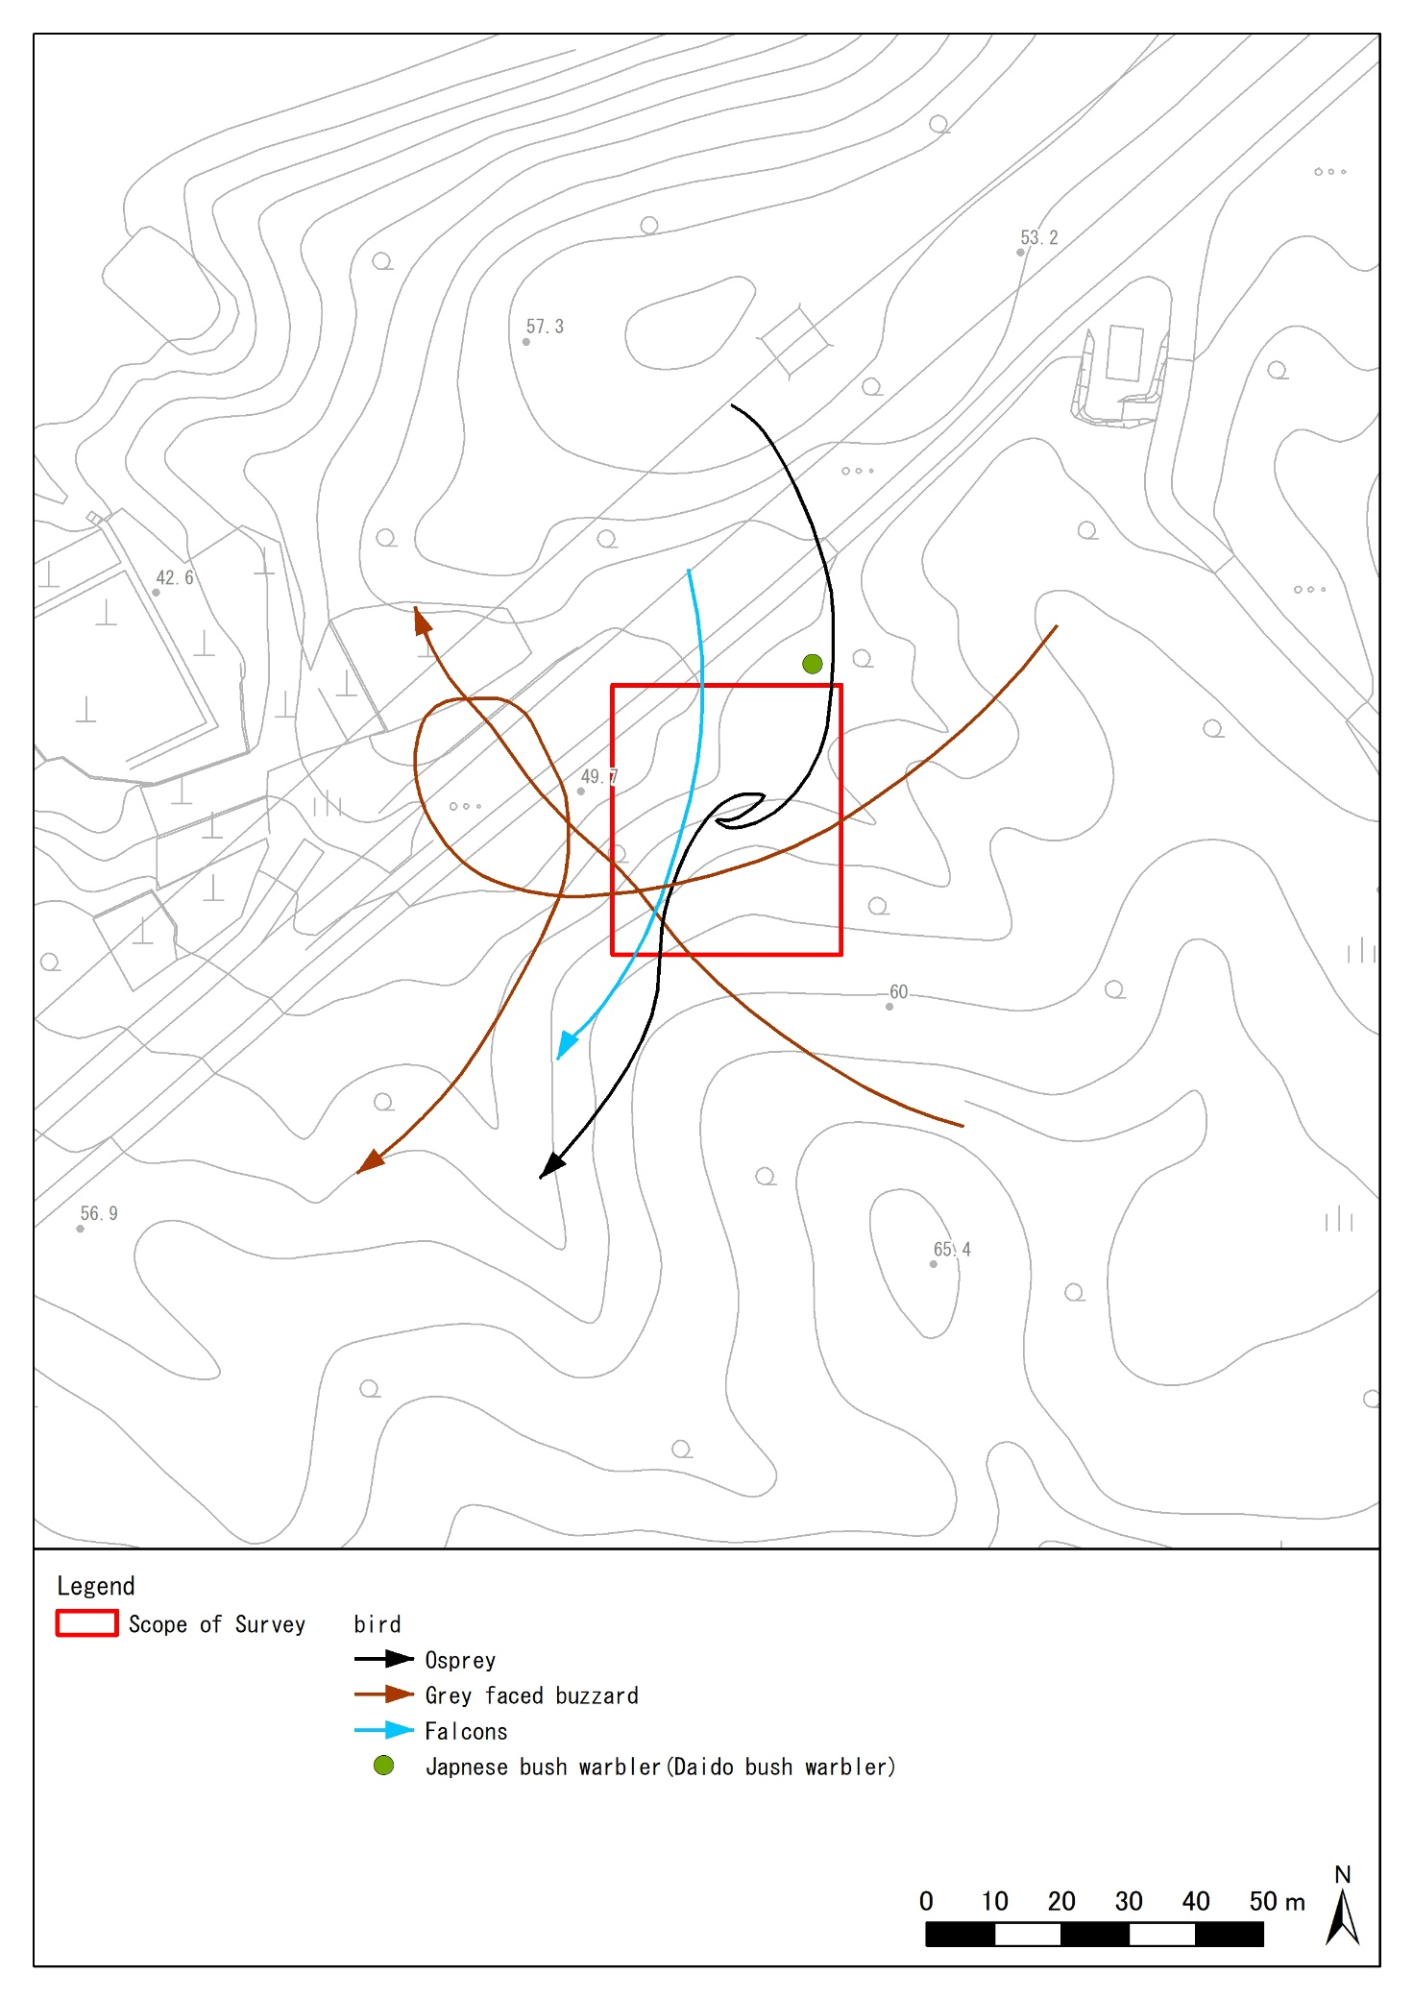

Figure 3‑4 Important species (birds) identified within the study area

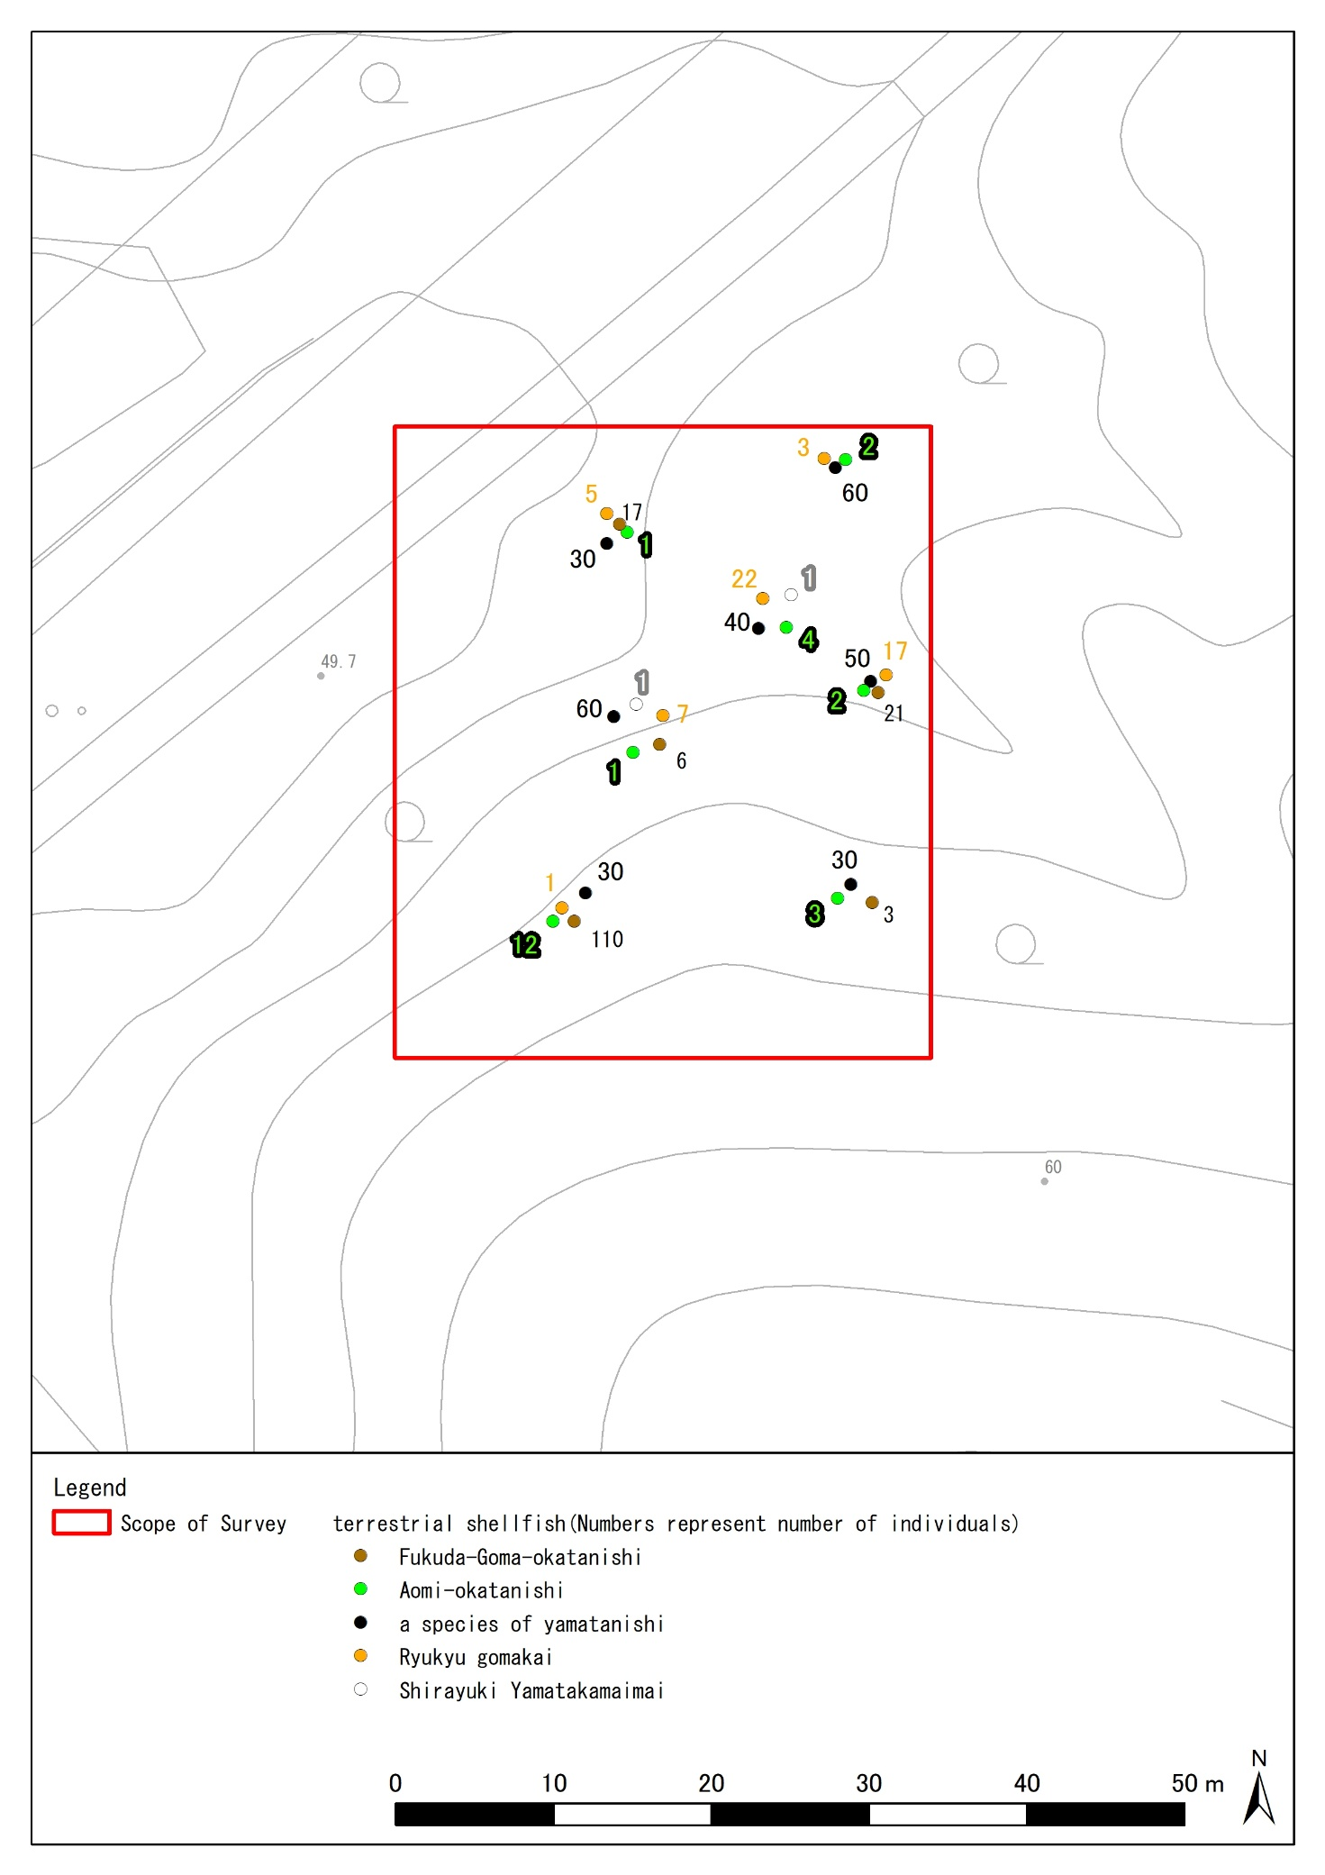

Figure 3‑5 Important species (terrestrial shellfish) identified within the study area

Table 3‑7 Coordinates of confirmed locations of target animals (World Geodetic System in 60 decimal notation)

|  |  |  |  |
| --- | --- | --- | --- |
| name of a species | population size | coordinate | |
| Japanese bush warbler | 1 | N26°16′54.73200″ | E127°45′16.67520″ |
| Fukuda-Goma-okatanishi | 17 | N26°16′54.60600″ | E127°45′16.80840″ |
| Fukuda-Goma-okatanishi | 21 | N26°16′54.62760″ | E127°45′17.24040″ |
| Fukuda-Goma-okatanishi | 3 | N26°16′54.41520″ | E127°45′16.29000″ |
| Fukuda-Goma-okatanishi | 110 | N26°16′54.50880″ | E127°45′15.92640″ |
| Fukuda-Goma-okatanishi | 6 | N26°16′54.49440″ | E127°45′15.60240″ |
| Aomi-okataishi | 1 | N26°16′55.08840″ | E127°45′16.38360″ |
| Aomi-okataishi | 2 | N26°16′55.08120″ | E127°45′16.45920″ |
| Aomi-okataishi | 2 | N26°16′55.28812″ | E127°45′16.60532″ |
| Aomi-okataishi | 3 | N26°16′54.92787″ | E127°45′16.24744″ |
| Aomi-okataishi | 12 | N26°16′54.89040″ | E127°45′16.40160″ |
| Aomi-okataishi | 1 | N26°16′54.86160″ | E127°45′16.45920″ |
| Aomi-okataishi | 4 | N26°16′54.80400″ | E127°45′16.56360″ |
| a species of yamatanishi | 30 | N26°16′53.73120″ | E127°45′15.33960″ |
| a species of yamatanishi | 60 | N26°16′53.83920″ | E127°45′15.24960″ |
| a species of yamatanishi | 50 | N26°16′53.87520″ | E127°45′15.23520″ |
| a species of yamatanishi | 30 | N26°16′53.99040″ | E127°45′15.21360″ |
| a species of yamatanishi | 30 | N26°16′53.91005″ | E127°45′14.88846″ |
| a species of yamatanishi | 60 | N26°16′54.58325″ | E127°45′15.67840″ |
| a species of yamatanishi | 40 | N26°16′54.84507″ | E127°45′16.05304″ |
| Ryukyu gomakai | 5 | N26°16′54.08040″ | E127°45′16.54920″ |
| Ryukyu gomakai | 3 | N26°16′53.53680″ | E127°45′16.04160″ |
| Ryukyu gomakai | 17 | N26°16′53.77800″ | E127°45′15.99840″ |
| Ryukyu gomakai | 1 | N26°16′53.87520″ | E127°45′15.40800″ |
| Ryukyu gomakai | 7 | N26°16′53.90040″ | E127°45′15.44400″ |
| Ryukyu gomakai | 22 | N26°16′54.06600″ | E127°45′15.76080″ |
| Shirayuki Yamatakamaimai | 1 | N26°16′53.99400″ | E127°45′15.75000″ |
| Shirayuki Yamatakamaimai | 1 | N26°16′54.07680″ | E127°45′15.68880″ |

TablE 3‑8 Coordinates of confirmed locations of target animals (Japan geodetic system in 60 decimal notation)

|  |  |  |  |
| --- | --- | --- | --- |
| Name of a species | population size | coordinate | |
| Japanese bush warbler | 1 | N26°16′40.63398″ | E127°45′23.39551″ |
| Fukuda-Goma-okatanishi | 17 | N26°16′40.50797″ | E127°45′23.52871″ |
| Fukuda-Goma-okatanishi | 21 | N26°16′40.52956″ | E127°45′23.96075″ |
| Fukuda-Goma-okatanishi | 3 | N26°16′40.31717″ | E127°45′23.01026″ |
| Fukuda-Goma-okatanishi | 110 | N26°16′40.41078″ | E127°45′22.64663″ |
| Fukuda-Goma-okatanishi | 6 | N26°16′40.39639″ | E127°45′22.32261″ |
| Aomi-okataishi | 1 | N26°16′40.99042″ | E127°45′23.10390″ |
| Aomi-okataishi | 2 | N26°16′40.98322″ | E127°45′23.17951″ |
| Aomi-okataishi | 2 | N26°16′41.19015″ | E127°45′23.32565″ |
| Aomi-okataishi | 3 | N26°16′40.82988″ | E127°45′22.96772″ |
| Aomi-okataishi | 12 | N26°16′40.79240″ | E127°45′23.12189″ |
| Aomi-okataishi | 1 | N26°16′40.76360″ | E127°45′23.17950″ |
| Aomi-okataishi | 4 | N26°16′40.70599″ | E127°45′23.28390″ |
| a species of yamatanishi | 30 | N26°16′39.63313″ | E127°45′22.05975″ |
| a species of yamatanishi | 60 | N26°16′39.74114″ | E127°45′21.96975″ |
| a species of yamatanishi | 50 | N26°16′39.77715″ | E127°45′21.95535″ |
| a species of yamatanishi | 30 | N26°16′39.89236″ | E127°45′21.93375″ |
| a species of yamatanishi | 30 | N26°16′39.81201″ | E127°45′21.60858″ |
| a species of yamatanishi | 60 | N26°16′40.48524″ | E127°45′22.39862″ |
| a species of yamatanishi | 40 | N26°16′40.74708″ | E127°45′22.77330″ |
| Ryukyu gomakai | 5 | N26°16′39.98233″ | E127°45′23.26946″ |
| Ryukyu gomakai | 3 | N26°16′39.43870″ | E127°45′22.76180″ |
| Ryukyu gomakai | 17 | N26°16′39.67992″ | E127°45′22.71860″ |
| Ryukyu gomakai | 1 | N26°16′39.77714″ | E127°45′22.12816″ |
| Ryukyu gomakai | 7 | N26°16′39.80234″ | E127°45′22.16416″ |
| Ryukyu gomakai | 22 | N26°16′39.96795″ | E127°45′22.48100″ |
| Shirayuki Yamatakamaimai | 1 | N26°16′39.89594″ | E127°45′22.47019″ |
| Shirayuki Yamatakamaimai | 1 | N26°16′39.97875″ | E127°45′22.40899″ |

### 2) Species to be surveyed (designated invasive alien species)

A list of identified animal species designated as invasive alien species is shown in Table 3‑9 and a list of identified species is shown in Table 3‑10. Points where species were identified are shown in Figure 3‑6. In addition, the latitude and longitude of the places where the animals designated as invasive alien species were identified are shown by the geodetic reference system in Table 3‑11, Table 3‑12.

Table 3‑9 List of designated invasive alien species (animals t to be surveyed )

|  |  |  |  |  |  |  |
| --- | --- | --- | --- | --- | --- | --- |
| No. | Classification | Family | Common name | Designated invasive alien species * 1 | List of invasive alien species to prevent damage to the ecosystems * 2 | Population |
| 1 | Mollusk | Geoplanidae | New Guinea flatworm | ○ | Alien species requiring urgent action | 2 |
| 2 | Amphibia | Rhacophoridae | White-lipped tree frog | ○ | Alien species requiring priority measures | 1 |
| Total | 2 classifications | 2 families | 2 species | 2 species | 2 species | 3 individuals |

*1 Designated invasive alien species: “Act on the Prevention of Adverse Ecological Impacts Caused by Designated Invasive Alien Species”

Species designated as invasive alien species ((alien species originating overseas) that cause or are likely to cause adverse impacts on ecosystems, human lives, and agriculture, forestry and fisheries. They are limited to living organisms, and include not only individuals but also eggs, seeds and organs.)

*2 List of invasive alien species to prevent damage to the ecosystems: “List of invasive alien species that pose risks of causing damage to ecosystems in Japan” (the Ministry of the Environment, the Ministry of Agriculture, Forestry and Fisheries, released on March 26, 2015)

■ Alien species to be prevented from establishment (alien species to be prevented from establishment): have not yet established themselves in Japan. Alien species that pose risks of causing damage to ecosystems if they have established in Japan. Therefore, prevention of introduction, monitoring at the water's edge, prevention of escape or establishment in the open, and early control if they are found, are needed.

(1) Alien species to be prevented from invasion: They have not invaded Japan yet. Therefore, it is necessary to prevent their invasion into Japan by preventing the introduction, monitoring at the water's edge, and countermeasures against ballast water.

(2) Other alien species to be prevented from establishment: There is information of their invasion but their establishment has not been confirmed.

■ Alien species requiring comprehensive measures (alien species requiring comprehensive measures): their establishment in Japan has been confirmed. Alien species that have caused or are likely to cause damage to ecosystems. Therefore, the national government, local governments, and citizens in their respective roles need to take comprehensive measures such as control (including removal in the open and prevention of their spreading), dissemination, and awareness raising to prevent abandonment, introduction, and escape.

(3) Alien species requiring urgent action: Alien species that meet any of the 1-4 criteria for the severity of damage AND 5 for the effectiveness and feasibility of measures based on the concept of priority of measures in the Action Plan for the Prevention of Damage from Invasive Alien Species.

(4) Alien species requiring priority measures: Alien species that meet any of the 1-4 criteria for the severity of damage based on the concept of priority of measures in the Action Plan for the Prevention of Damage from Invasive Alien Species.

(5) Other alien species requiring comprehensive measures: the concept of priority of measures against (3) Alien species requiring urgent action and (4) Alien species requiring priority measures

Criteria for the severity of damage

1. Potential impacts and damages on ecosystems are particularly severe

2. Highly likely to invade and establish areas that are important for conservation of biodiversity and cause damage

3. Highly likely to cause severe damage to the habitat and growth of endangered species

4. Effectiveness and feasibility of measures against invasive alien species that cause serious damage to human life and health, and society and economy such as agriculture, forestry, and fisheries

5. There is a certain level of knowledge such as that control methods have been developed or are likely to be developed, and goals for countermeasures can be established.

■ Industrially important alien species requiring appropriate control (industrially controlled alien species)

(6) Industrially controlled alien species: Alien species that are important in industry or public interest, are irreplaceable, and require appropriate control for their use. They require proper control by indicating precautions for use for each species.

Table 3‑10 List of Confirmed Species of Specified Invasive Alien Species

|  |  |
| --- | --- |
| 屋外, 動物, 座る, 作品 が含まれている画像  AI によって生成されたコンテンツは間違っている可能性があります。 | ■Morphological Features  A 40-65 mm long terrestrial planarian. Dorsal surface blackish brown with thin white vertical lines. Ventral surface light gray. Head narrower than rear.  ■Distribution Area  Natural distribution is in New Guinea. In Japan, the invasion was confirmed in October 1990 on southern Okinawa Island.  Habitat  Forests and grasslands in warmer regions.  Impact on ecosystems, etc.  It preys on ground and arboreal snails. It is also the L3 intermediate standby host of the Guangdong resident nematode, and is orally transmitted to humans.  ■Measures  Limit soil movement. Also, wash shoe soles and other items that come in contact with soil with salt water, as they are vulnerable to seawater. |
| Common name: New Guinea flatworm  Scientific name: *Platydemus manokwari*  Classification: Geoplanidae（Tricladida）  category  Designated invasive alien species  List of invasive alien species to prevent damage to the ecosystems（Alien species requiring urgent action） |
| 岩の上にいるカエル  AI によって生成されたコンテンツは間違っている可能性があります。 | ■Morphological Features  Body length 47-73 mm; body color brown, sometimes with a few black streaks on the back. Scratches between the digits of all limbs very poorly developed.  ■Distribution Area  Its natural distribution is almost all over Southeast Asia from northeastern India to the Philippines. In Japan, the invasion was confirmed on Okinawa Island in 1964 and on Miyako Island in 1997.  Habitat  Common in relatively open environments such as residential areas, shrublands, and secondary forests. It is also found in natural forests.  Impact on ecosystems, etc.  Competition for food and spawning sites, interference with breeding activities by singing, and non-native parasites (helminths) have been identified, and there is concern about infection of native amphibians.  ■Measures  Removal of egg masses and larvae at breeding sites is possible. Adults are inconspicuous and difficult to capture in clusters. Frequent visits to breeding sites and frequent removal of adults, foam nests, and larvae that are found may be a practical approach. |
| Common name: White-lipped tree frog  Scientific name: *Polypedates leucomystax*  Classification: Anuranidae (green frogs)  category  Designated invasive alien species  List of invasive alien species to prevent damage to the ecosystems (Alien species requiring priority measures) |

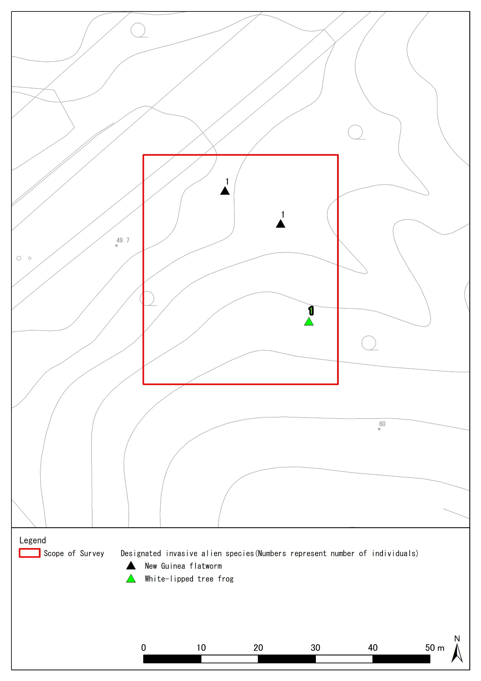

Figure 3‑6 Specified Invasive Alien Species identified within the study area

Table 3‑11 Coordinates of confirmed locations of designated invasive alien species (World Geodetic System in 60 decimal notation)

|  |  |  |  |
| --- | --- | --- | --- |
| name of a species | population size | coordinate | |
| New Guinea flatworm | 1 | N 26°16′54.40440″ | E 127°45′16.04880″ |
| New Guinea flatworm | 1 | N 26°16′54.40440″ | E 127°45′16.04880″ |
| White-lipped tree frog | 1 | N 26°16′54.29280″ | E 127°45′15.91200″ |

Table 3‑12 Coordinates of confirmed locations of designated invasive alien species (Japan geodetic system in 60 decimal notation)

|  |  |  |  |
| --- | --- | --- | --- |
| name of a species | population size | coordinate | |
| New Guinea flatworm | 1 | N 26°16′40.30637″ | E 127°45′22.76904″ |
| New Guinea flatworm | 1 | N 26°16′40.30637″ | E 127°45′22.76904″ |
| White-lipped tree frog | 1 | N 26°16′40.19476″ | E 127°45′22.63222″ |

# Estimation of the impacts of the archaeological excavation survey and examination of conservation measures

## Conservation of the conservation

The estimation of the impacts of the archaeological excavation survey on the natural and cultural property features of this survey site and the proposed conservation measures for them are shown in Table 4‑1.

Table 4‑1 Estimated impacts on the natural and cultural property features and the proposed conservation measures for them

|  |  |  |
| --- | --- | --- |
| Natural and cultural property features | Estimated impacts | Proposed conservation measures |
| Limestone geology | Loss of animal habitat due to moving stones | The present status of the stones should be maintained, and if moving the stones, move them to a place where they will not be altered along with the animals living under them. |
| Surrounding forests | Death of shrubs and herbs by trampling | Do not enter outside of the survey area unnecessarily. If entering, set the work path so that the influence of trampling in other areas won’t occur. |
| Tomb ruins | Weathering of tomb due to drying caused by vegetation loss on and around tomb. | Conservation of medium to tall trees (5-10 m height) |

## Conservation of plants to be surveyed

Conservation measures for surveyed plants are shown in Table 4‑2.

Table 4‑2 Proposed conservation measures for plants to be surveyed

|  |  |  |
| --- | --- | --- |
| Common name | Estimated impacts | Proposed conservation measures |
| Kuwanohaenoki | Death by cutting and pruning | Preserve individual plants as much as possible to conserve them |
| Ryukyu Kokutan | Death by pruning | Prune directly above its blastema so that the regenerating tissue can easily cover the section.  (Refer to natural target cutting [Figure 4‑1]) |

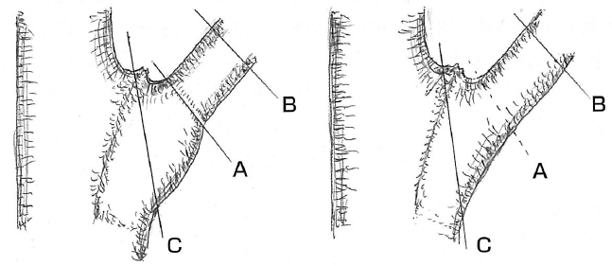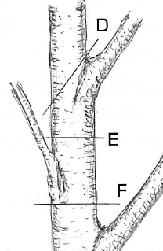

[Method to select branches]

Cut a branch while leaving the swollen part

[Method to select trunks]

Cut diagonally along a branch from a branching part

The cutting surface is covered with wound-healing tissue and does not rot easily

Cut diagonally to reduce the withering parts.

Reference: Manual for Tree Doctors: the 4th edition Japan Greenery Research and Development Center

**○**

**○**

**○**

**×**

**×**

**×**

**×**

**×**

**×**

Figure 4‑1 Reducing the impacts on trees through proper selection (natural target cutting)

## Conservation of animals to be surveyed

Conservation measures for surveyed animals are shown in Table 4‑3.

Table 4‑3 Proposed conservation measures for animals to be surveyed

|  |  |  |
| --- | --- | --- |
| Common name | Estimated impacts | Proposed conservation measures |
| Fukuda-Goma-okatanishi | Loss of habitat (earth environment) | • Conserve woody plants with a diameter of 5 cm or more at breast height and herbs as much as possible (conservation plants with sign tape must be conserved at least)  • Leave fallen trees and stones without moving or destroying them unnecessarily.  • Do not enter outside of the survey area unnecessarily to avoid trampling on the habitat.  • Maintain a space such as a cave. |
| Aomi-okatanishi | Loss of habitat (environment on a tree) |
| a species of yamatanishi | Loss of habitat (earth environment) |
| Ryukyu gomakai | Loss of habitat (earth environment) |
| Shirayuki Yamatakamaimai | Loss of habitat (environment on a tree) |
| Okinawa tree lizard  (Unconfirmed *1) | Loss of habitat (environment on a tree) |
| Great nawab  (Unconfirmed *2) | Loss of habitat (environment on a tree) |
| Kuroiwa's ground gecko  (Unconfirmed *3) | Loss of habitat (earth environment) |
| Terrestrial Hermit Crabs  (Unconfirmed *4) | Loss of habitat (earth environment) |
| Orii's flying-fox  (Unconfirmed *5) | Loss of habitat (environment on a tree) |
| Cave-dwelling bats  (Unconfirmed *6) | Loss of habitat  (environment on a tree, and spaces such as caves) |

Note) Despite of being unidentified, species are likely to be present because of the following reasons:

*1: Okinawa tree lizard is highly likely to be present since its inhabitation was confirmed in the surveys in past years.

*2: The great nawab is likely to fly in since its individuals have been observed in the vicinity.

*3: Kuroiwa's ground gecko is likely to live in the area since the limestone geology is suitable for their habitat.

*4: Terrestrial Hermit Crabs may live in the area since they for hermit crabs due to sightings.

*5: Orii's flying-foxes have been observed in the vicinity and may fly.

*6:Cave-dwelling bats may inhabit the forest because tomb have spaces that resemble a cave.

## Measures against designated invasive alien species

Proposed measures against identified invasive alien species are shown in Table 4‑4.

Table 4‑4 Proposed measures against designated invasive alien species

|  |  |  |
| --- | --- | --- |
| Common name | Estimated impacts | Proposed conservation measures |
| New Guinea flatworm | • Impacts of predation on native land shellfish | • Prevent the spread of fallen leaves and branches that serve as its habitat |
| White-lipped tree frog | • Impacts of predation on native insects  • Competition for habitats and breeding sites | • Prevent water areas for their spawning (pay attention to small water areas such as buckets because they can spawn there)  • Remove egg masses (foam nests), which may be found in water areas during the breeding season of May to October |

# Summary

The following points should be taken into consideration for the conservation of the ecosystem in the survey site during the archaeological excavation survey.

**1. Keep out of the woods**

Trampling can kill shrubs and herbs, and destroy animal habitats and breeding environments.

**2. Use natural target cutting for pruning trees**

It can minimize damage to trees.

**3. Do not move or destroy natural objects unnecessarily**

It can destroy the growth, habitats, and breeding environments of animals and plants.

**4. Implement measures against designated invasive alien species**

It aims to preserve native flora and fauna in Japan.

■ Method of natural target cutting



[Method to select branches]

Cut a branch while leaving the swollen part

[Method to select trunks]

Cut diagonally along a branch from a branching part

The cutting surface is covered with wound-healing tissue and does not rot easily

Cut diagonally to reduce the withering parts.

Reference: Manual for Tree Doctors: the 4th edition Japan Greenery Research and Development Center

**○**

**○**

**○**

**×**

**×**

**×**

**×**

**×**

**×**

■ Examples of measures against designated invasive alien species

• Prevent the spread of fallen leaves and branches that serve a habitat for New Guinea flatworm (designated invasive alien species).

• Prevent water areas for spawning ground of White-lipped tree frogs (designated invasive alien species) (pay attention to small water areas such as buckets because they can spawn there).

• Remove egg masses (foam nests) of White-lipped tree frogs (designated invasive alien species). Any size of water area can be a spawning ground during the breeding season of May to October.

# Reference

## Bibliography

・Okinawa Prefecture Guidelines for Environmental Survey of U.S. Military Bases. Okinawa Prefecture.2017.

・Red Data Book 2014 - Endangered and Threatened Wildlife in Japan -. Ministry of the Environment.2014.

・Ministry of the Environment Red List 2020. Office for Conservation of Rare Species, Wildlife Division, Nature Conservation Bureau, Ministry of the Environment. 2020.

・Revised and Endangered Wildlife of Okinawa Prefecture, Third Edition (Fungi and Plants) - Red Data Okinawa-. Nature Conservation Division, Department of Environment, Okinawa Prefecture.2018.

・In: Revised edition of Endangered Wildlife of Okinawa Prefecture, 2nd edition (Animals). Nature Conservation Division, Department of Environment, Okinawa Prefecture. 2005.

・Revised and Updated: Threatened Wildlife of Okinawa Prefecture, 3rd Edition (Animals). Nature Conservation Division, Department of Environment, Okinawa Prefecture.2017.

・List of Invasive Alien Species with the Potential to Harm Japanese Ecosystems [List of Invasive Alien Species for the Prevention of Ecosystem Damage]. Ministry of the Environment, Ministry of Agriculture, Forestry and Fisheries. 2015.

・Invasive Alien Species in Japan. Nature Conservation Research Center.2019.

・Nature Guide to the Trees of the Ryukyus. Okawa, T. and Hayashi, M. 2016.

・Okinawa Botanical Field Guide. Ikehara, Naoki. 1979.

・The latest tree surgeon's guide, revised 4th edition. Japan Arboriculture Center. 2015.

・Ryukyu Plants Database. Flora of the Ryukyus Research Group.2018 (updated year).

https://www.kahaku.go.jp/research/activities/project/hotspot_japan/ryukyus/db/

・Wing Length as a Criterion for Sex Identification of Japanese Cormorant Phalacrocorax carbo in Marking Studies. Abe, N. 1984.

## Photos

|  |  |
| --- | --- |
| 屋外, 人, 持つ, 男 が含まれている画像  AI によって生成されたコンテンツは間違っている可能性があります。 | 屋外, 草, クマ, 若い が含まれている画像  AI によって生成されたコンテンツは間違っている可能性があります。 |
| Survey status (confirmed inhabitation of the prefecture-designated natural monument, the Futao butterfly)  January 21, 2025 | Survey status (confirmed habitat of the black-tailed lizard, a natural treasure designated by the prefecture)  January 21, 2025 |
| 草の上に座っている男性  AI によって生成されたコンテンツは間違っている可能性があります。 | 草の上に立っている男性  AI によって生成されたコンテンツは間違っている可能性があります。 |
| Survey status (confirmation of the habitat of the nationally-designated natural treasure, the hermit crab)  January 21, 2025 | Survey status (Confirmation of the growth of food plants (food trees) of the prefecture-designated natural monument, the phytophagous butterfly)  January 21, 2025 |
| 男, 持つ, 立つ, 記号 が含まれている画像  AI によって生成されたコンテンツは間違っている可能性があります。 | 屋外, ベンチ, 読書, 座る が含まれている画像  AI によって生成されたコンテンツは間違っている可能性があります。 |
| Survey status (growth and habitat confirmation of rare plants and animals)  January 21, 2025 | Survey status (survey of vegetation communities comprising the vegetation in the area)  January 21, 2025 |

|  |  |
| --- | --- |
| 屋外, 草, 記号, 読書 が含まれている画像  AI によって生成されたコンテンツは間違っている可能性があります。 | 草の上にいろいろな帽子をかぶっている男性  AI によって生成されたコンテンツは間違っている可能性があります。 |
| Survey status (Confirmation of growth of specified invasive alien species)  January 21, 2025 | Status of KY (hazard prediction) activities  January 21, 2025 |